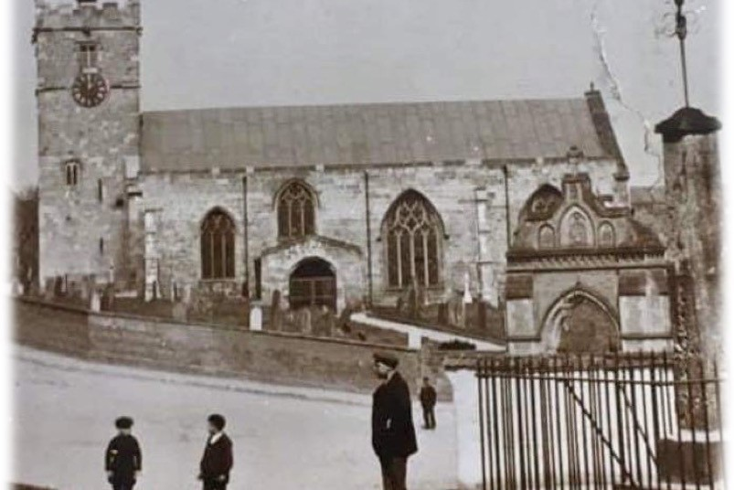

HUNMANBY SURGERY | PATIENT SURVEY RESULTS SEPTEMBER 2023

GP Practice Patient Survey –September 2023
Hunmanby Surgery
Analysis & Feedback

- Appointments

If you need to be seen urgently we will try our best to give you an appointment on the same day. This appointment might not be with your regular doctor. If you need a non-urgent appointment we will try our best to give you an appointment within two weeks of your call.
Considering this appointment system, please tell us how much you agree with the following statements
 | Strongly agree | Strongly  Disagree | Disagree | Agree | Neither agree nor disagree
a) If I need an urgent appointment, I am usually seen the same day | 17 |  | 9 | 11 | 3
b) If I need a non-urgent appointment, I am usually given a choice of time or day | 11 |  | 5 | 19 | 3
c) I am given a choice of healthcare professional best suited to my needs | 6 |  | 3 | 19 | 10
d) I am given a choice of healthcare professional best suited to my needs | 6 |  | 2 | 21 | 5

- Describe your experience of making an appointment.

Overall, how would you describe your experience of making an appointment.

 | Strongly agree | Strongly  Disagree | Disagree | Agree | Neither agree nor disagree
a) Very good | 17 | 0 | 1 | 10 | 1
b) Fairly good | 5 | 0 | 1 | 9 | 0
c) Neither good nor poor | 0 | 2 | 2 | 4 | 1
d) Fairly poor | 0 | 3 | 2 | 2 | 0
e) Very poor | 0 | 3 | 3 | 0 | 0

- Doctor Jaidev’s Ability to Communicate with Patients

I am seeking my patients’ views on what they feel about my professional behaviour and practice, and whether they think I could improve the way I work. Please give your honest views
 | Strongly agree | Strongly  Disagree | Disagree | Agree | Neither agree nor disagree
a) Listening to patients | 29 | 0 | 0 | 10 | 1
b) Communicating effectively | 23 | 0 | 0 | 12 | 1
c) Were you given enough time at your consultation | 22 | 0 | 1 | 12 | 3
d) Friendliness during the consultation | 25 | 0 | 0 | 10 | 0
e) Showing respect | 25 | 0 | 0 | 11 | 0
f) Involving you in decisions about your care | 21 | 1 | 2 | 9 | 1
g) The GP recognised any mental health needs during your appointment | 6 | 1 | 1 | 3 | 17
h) You were treated with care and concern during your consultation | 25 | 0 | 0 | 15 | 0
i) You left the practice with trust in your GP and confidence in your consultation | 19 | 0 | 0 | 12 | 2

4. Doctor D'Silva's Ability to Communicate with Patients

I am seeking my patients’ views on what they feel about my professional behaviour and practice, and whether they think I could improve the way I work. Please give your honest views.
 | Strongly agree | Strongly  Disagree | Disagree | Agree | Neither agree nor disagree
a) Listening to patients | 17 | 1 | 1 | 9 | 1
b) Communicating effectively | 17 | 1 | 1 | 10 | 1
c) Were you given enough time at your consultation | 17 | 1 | 1 | 11 | 3
d) Friendliness during the consultation | 19 | 1 | 0 | 9 | 0
e) Showing respect | 19 | 1 | 0 | 9 | 0
f) Involving you in decisions about your care | 16 | 0 | 1 | 9 | 1
g) The GP recognised any mental health needs during your appointment | 8 | 0 | 1 | 2 | 16
h) You were treated with care and concern during your consultation | 16 | 1 | 1 | 12 | 1
i) You left the practice with confidence in your consultation | 15 | 1 | 0 | 9 | 5

6. Pharmacist Ability to Communicate with Patients
I am seeking my patients’ views on what they feel about my professional behaviour and practice, and whether they think I could improve the way I work. Please give your honest views.
 | Strongly agree | Strongly  Disagree | Disagree | Agree | Neither agree nor disagree
a) Listening to patients | 15 | 0 | 2 | 4 | 4
b) Communicating effectively | 13 | 0 | 2 | 6 | 4
c) Were you given enough time at your consultation | 14 | 0 | 0 | 6 | 5
d) Friendliness during the consultation | 14 | 0 | 1 | 7 | 4
e) Showing respect | 15 | 0 | 1 | 6 | 4
f) Involving you in decisions about your care | 10 | 0 | 1 | 9 | 5
g) The Pharmacist recognised any mental health needs during your appointment | 6 | 0 | 0 | 2 | 14
h) You were treated with care and concern during your consultation | 13 | 0 | 1 | 7 | 4
i) You left the practice with confidence in your consultation | 10 | 0 | 1 | 8 | 6

7. Nurse Appointments
Last time you saw or spoke to a Nurse, how good was the consultation. Considering this, please tell us how much you agree with the following statements.
 | Strongly disagree | Disagree | Neither agree nor disagree | Agree | Strongly agree
a) Listening to patients | 3 | 0 | 0 | 7 | 32
b) Communicating effectively | 3 | 0 | 0 | 7 | 26
c) Were you given enough time at your consultation | 3 | 0 | 0 | 5 | 27
d) Friendliness during the consultation | 3 | 0 | 0 | 6 | 26
e) Showing respect | 3 | 0 | 0 | 5 | 27
f) Involving you in decisions about your care | 3 | 0 | 1 | 5 | 24
g) The Nurse recognised any mental health needs during your appointment | 4 | 0 | 8 | 0 | 13
h) You were treated with care and concern during your consultation | 3 | 0 | 0 | 6 | 28
i) You left the practice with confidence in your consultation | 3 | 0 | 0 | 7 | 23

8. Reception Staff

How helpful do you find the reception staff at our practice.
 | Strongly disagree | Disagree | Neither agree nor disagree | Agree | Strongly agree
a) Very helpful | 3 | 0 | 0 | 5 | 30
b) Fairly helpful | 1 | 1 | 0 | 4 | 5
c) Not very helpful | 3 | 3 | 0 | 1 | 2
d) Not at all helpful | 3 | 4 | 0 | 0 | 2
e) Bad/rude attitude | 5 | 2 | 0 | 0 | 2

9. Practice Opening Times

We appreciate that many patients need flexibility. Our current opening times are

Mon | Tues | Wed | Thurs | Fri | Sat | Sun
8.00am – 6.00pm  Enhanced  Access Opening | 8.00am – 6.00pm | 8.00am – 6.00pm | 8.00am – 6.00pm  6.30pm – 8.30pm | 8.00am – 6.00pm | Closed | Closed
Considering our opening times, please tell us how much you agree with the following statements.

 | Strongly disagree | Disagree | Neither agree nor disagree | Agree | Strongly agree
a) The practice is open at times when I can attend an appointment | 2 | 0 | 1 | 12 | 20
b) The practice is not open at a time I am able to attend | 9 | 6 | 5 | 1 | 1
c) I am happy with the current opening times. | 2 | 0 | 1 | 14 | 17
d) I am unhappy with the current opening times | 9 | 5 | 3 | 1 | 2
e) I am happy with the Out of Hours Service | 2 | 3 | 8 | 5 | 9

10. Our Surgery
We want to make your visit to the surgery as pleasant as possible. Please tell us how much you agree with the following statements
 | Strongly disagree | Disagree | Neither agree nor disagree | Agree | Strongly agree
a) The staff are friendly and approachable
b) Patients are treated fairly
c) I am satisfied with the disabled access and facilities

11. Prescriptions

Medication is often an important part of people’s treatment, and some people require repeat prescriptions. The practice aims to have all repeat prescriptions ready within 5 days of the patient requesting the prescription.
 | Strongly disagree | Disagree | Neither agree nor disagree | Agree | Strongly agree
a) When I request a repeat prescription, it is always ready within 5 days | 2 | 2 | 2 | 18 | 11
b) I utilise the online prescription ordering facility or the NHS App to order medication | 2 | 3 | 8 | 7 | 3
c) I prefer to bring my repeat ordering slip to the practice or order with the reception team | 1 | 5 | 1 | 4 | 9
d) Pharmacies order medication on my behalf | 2 | 2 | 6 | 5 | 7

12. Friends & Family Test

We aim to be a practice that you would be happy to recommend to your friends and family. Please tell us how much you agree with the following statement:
 | Strongly disagree | Disagree | Neither agree nor disagree | agree | Strongly agree
I would be likely to recommend Hunmanby Surgery to friends and family if they needed similar care or treatment. | 2 | 0 | 4 | 10 | 19

13. Attending Appointments

Failure to attend appointments is costly in both time and finance, if you have missed an appointment in the last 12 months could you tell us why you were unable to attend, cancel or re-arrange, please tick the answer that is most appropriate.
I’ve never failed to attend | 21
I did not have time to attend | 0
I was unable to leave someone I care for | 1
I could not get out of work | 0
I could not get through to the practice by phone | 0
The practice was closed when I could have phoned | 0
I had no transport on the day | 0
I had no childcare facilities in place | 0
Other (please specify) | 3

Equality monitoring (need to alter these boxes)

By filling in this equality monitoring section you will help us ensure that we get feedback from all the different communities in our area. Filling in this section is optional. Any information is kept in strict confidence. Are you?
Age | Male | Female | Prefer not to say | Prefer to self  Describe
Under 16 | 1
17-24
25-34
35-44
45-54 |  | 2
55-64 | 4 | 6
65-74 | 3 | 5
75-84 | 2 | 7
84+

How often do you visit our surgery?

Often Rarely Very Rarely

